How to Import a data file onto SAS, Enter code and Run the code:

* If the data does not have column heading give column headings in excel before importing. If SAS gives you an error importing the .xlsx file import the .csv file.

How to import a file into SAS:

File

Import Data

Select the data source – Next

Browse and find the file – Ok

Next

Library – Work

Give a member (file name) – Next

Finish

* The data can be found on the left panel under Library – Work

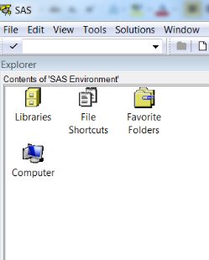

* Type your code into the Editor as shown bellow and make sure to save your code:

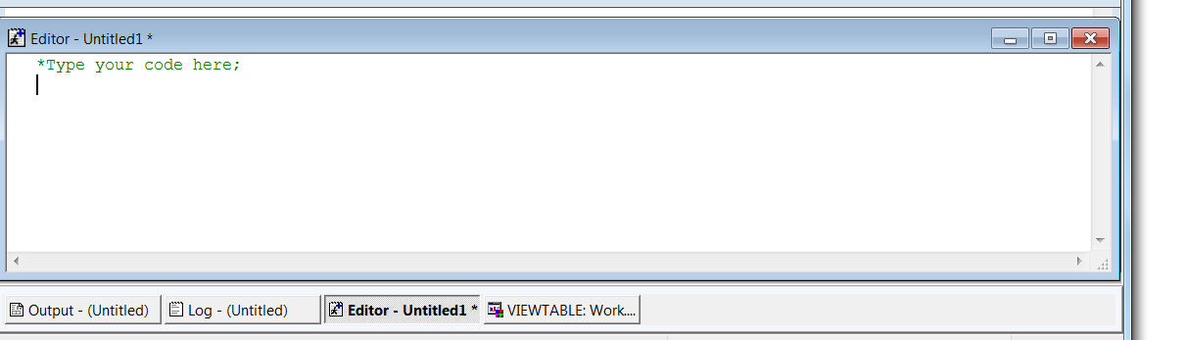

* To run your code, press the symbol with the running man:

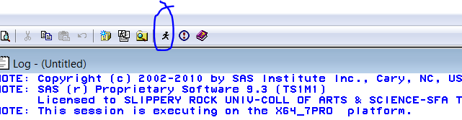

* Check your log for errors, etc.:

